ECON. 2004-05: SECTION 4: INTERNATIONAL ECONOMICS STANDARD

4.1 REASONS FOR TRADE

4.1.1 Differences in Factor Endowments

- Trade is based on the concept of opportunity cost: if a country can produce one good at a lower opportunity cost than another country, it has a comparative advantage. It sacrifices less of other goods to make one unit of that good.
- Gains from trade are the increased output resulting from specialization amongst nations and from trading are called the gains from trade. They lead to an increase in living standards, but also to increased dependence amongst nations.
- Differences in factor endowments lead to differences in opportunity costs. Countries where land is cheap and labour is expensive will produce land intensive goods. Countries where there is little land but abundant labour will produce labour intensive goods.
- The Hecksher Ohlin theory: countries have comparative advantages in the production of goods in which they have relatively abundant endowments of natural resources including climate and weather.

4.1.3 Gains from Specialization

- Arguments for free trade are comparative advantage, economies of scale, increased competition and the spread of technology.
- However, in the real world, countries do not specialize totally:
- Opportunity costs are not constant in the real world.
- Opportunity costs between land intensive products and capital intensive products will change as specialization proceeds.

- Transport costs are ignored in the model, but do place limits on trade in the real world.
- Another limit to the trade in goods and services is the mobility of the factors of production:
- It is in the interests of the owners of factors of production to move them to the highest paid location.
- Labour tends to move from low wage to high wage countries.
- Capital moves from low ROI to high ROI countries.
- All this movement in factors tends to alter the comparative advantages of regions and nations over time.

Economies of Scale
- Unit costs of production usually fall over some range of production as the scale increases, because some types of K are simply more efficient in large scale production.
- For smaller countries, the domestic market is simply too small to make it worthwhile building large plants. Trade allows these smaller countries to specialize in producing a limited range of commodities at high enough levels of output that they will reap the available economies of scale.
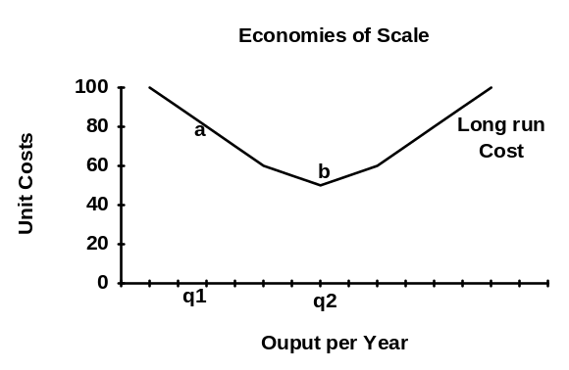
- Free trade leads to differentiated products with different countries specializing in different sub product lines.

Learning by Doing
- Countries that specialize in a particular line of production gain experience both in terms of the workers and the managers. The whole cost curve actually falls.
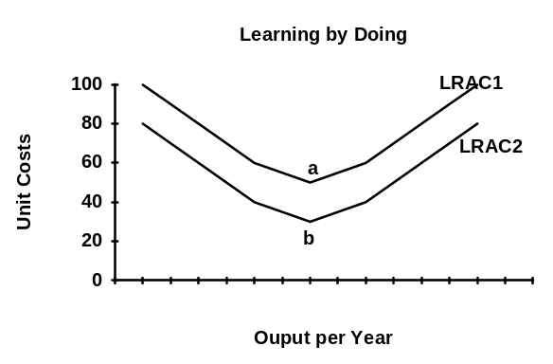
- It is particularly important in knowledge intensive, high tech industries: costs fall as the total of all cumulative past output rises (the Σq rather than the level of q).

- The higher a firm's output, the faster unit costs will fall. This confers large advantages on firms which are first into the market with a new product or service, and benefits firms that have large domestic markets to support an initial high rate of output.

4.1.4 Political

- Comparative advantages can be altered. Through education and investment, countries can develop new comparative advantages.
- Misguided education policies, tax policies that discourage investment and risk taking can lead to a rapid erosion of a country's comparative advantage.

- Old view: factor endowments determined the patterns of comparative advantage, and those countries large enough to gain economies of scale had a comparative advantage over smaller countries. With trade, each country would specialize in the products in which it had a comparative advantage and by trading would access larger markets leading to economies of scale.

- New view: new industries depend as much on human capital which is developed through training and learning by doing, conferring a new type of comparative advantage.
- Private entrepreneurial activity plus govt. intervention to promote education and investment can alter comparative advantage. The question is whether govt. intervention can accomplish the task and at what cost.

4.2 FREE TRADE & PROTECTIONISM

4.2.1 Definition of Free Trade

- With free trade there is no govt. intervention to constrain trade or alter trade patterns.
- Protectionism is govt. intervention designed to protect domestic industry from foreign competition and occurs through price controls (tariffs), quantity controls (quotas), and non-tariff barriers (NTBs) which are regulatory in nature and designed to hinder the flow of imports.

4.2.2 Types of Protectionism

Tariffs
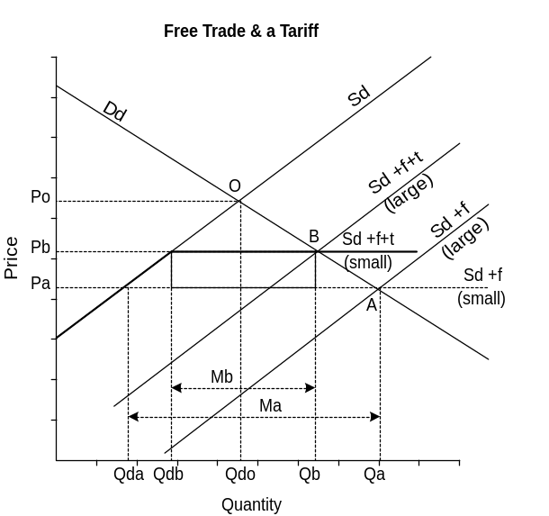
- Tariffs are import duties: a specific tariff is one that is levied as a specified amount of money on each imported unit. An ad valorem tariff is levied as a tax percent of the price.
- In some LDCs which have trouble collecting income taxes, tariffs remain a very important source of revenue.
- Example: the domestic price before trade is Po producing at Q_{do}.
- After trade, which leads to a shifting out of the supply curve, the price falls to the world level of P_{a}, quantity consumed is Q_{a}, of which only Q_{da} is produced domestically.
- Domestic producers are not happy as they have lost production and revenue has fallen to P_{a}*Q_{da}.

- If a tariff is imposed by a small country:
- The supply curve begins with domestic production and prices rise to P_{b}. The new supply curve is S_{d+f+t}.(small)
- The quantity consumed drops to Q_{b}, domestic producers increase production to Q_{db}, and their total revenue rises to P_{b}*Q_{db}.
- The govt. receives the revenue given by the difference between Q_{b} and Q_{db} times price P_{b}-P_{a}.
- Domestic consumers lose because they consume less of the product and they have to pay a higher price.
- Foreign exporters receive (Q_{b} - Q_{db})*P_{a}

- If a tariff is imposed by a large country, the analysis is virtually the same except that the new supply curve is upward sloping S_{d+f+t}.(large) to reflect the influence on world prices of the buying power of a large country.

Quotas
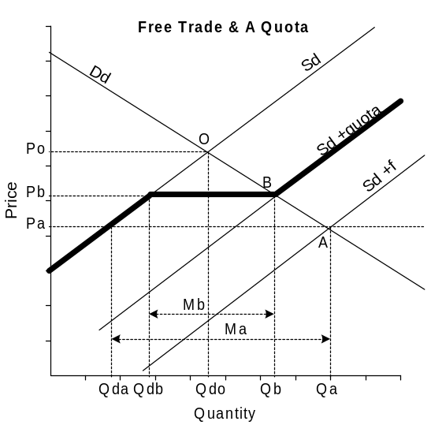
- An import quota is a restriction on the amount that can be imported (Q_{b} - Q_{db}).
- The situation is the same for domestic producers as with the tariff.
- But importers now receive the revenue the govt. used to receive.
- The total supply curve consists of the heavy black line: the domestic segment from zero to Q_{db}, plus the foreign segment from Q_{db} to Q_{b}, then back to the domestic segment from P_{b} on.
- In the absence of a quota, equilibrium would have taken place along the foreign supply curve, S_{d+f} at P_{a} and Q_{a}.

Subsidies
- There are a number of policies used by governments to promote exports:
- Financial incentives to export producers, usually referred to as subsidies, to lower production costs and in order to shift the domestic supply curve to the right.
- Export credit and guarantees, operation of overseas export promotion agencies, establishment of Free Trade Zones, Exchange rate manipulation.

Voluntary Export Restrictions
- Voluntary export restrictions are imposed by a foreign govt. on its own exports and is a way of getting around the WTO rules which forbid tariffs and quotas.

Administrative Obstacles
- Non-tariff barriers (NTBs) are erected by govt., usually through some regulation, which impedes the flow of imports into a country without the use of tariffs or quotas. One of the problems that has arisen from GATT is the set of rules designed to assist with NTB's.
- What were originally temporary measures often become permanent.
- Exchange controls limit the amount of foreign currency available to exporters.
- Import licensing is a way of rationing imports.

Health and Safety Standards
- Health and safety standards may be imposed which make it expensive for an importer to compete by requiring certain safety or health standards for products.

Environmental Standards
- Countries may impose environmental standards on production in order to preserve natural and environmental resources.
- To prevent TNCs from shifting production to countries with lower environmental standards, countries may impose tariffs or environmental taxes on incoming goods to “make the playing field more even”. This is an attempt to stop firms from exploiting the differences in environmental standards.

4.2.3 Arguments for Protectionism

Infant Industry Argument
- If an industry can gain large economies of scale, the domestic govt. will protect it until it has reached a large enough size to experience those economies of scale.
- The country with an industry which is first to reach the lowest LRAC can produce more cheaply and gain the largest market share, a great advantage.
- Often the protection leads to inefficiency so that when the tariff is removed, the industry cannot compete.

Efforts of a developing country to diversify
- Increased specialization leads to greater dependence which may not be good for national security reasons
- For national security reasons countries impose tariffs.
- For human development reasons tariffs are imposed to ensure:
- A wider range of occupations to choose from
- Learning by doing
- Greater diversification which leads to less dependence.

- Specialization can be risky: a new technological breakthrough can render the main production obsolete.
- If a country is specialized in primary goods, market swings in prices and consumption are more violent than for manufactured goods or services.
- Who chooses which industries are going to be the winners? Govts. have shown they are no good at choosing.

Protection of Employment
- The sale of surplus food by the EU on international markets hurts employment in LDCs.
- Strategic trade policies by large countries can hurt manufacturing employment in LDCs.
- Groups of countries may alter the terms of trade: for example OPEC which can hurt employment.
- There is a great deal of pain in the transition from protection to free trade, many firms go bankrupt and many people lose their jobs.
- Infant industry protection is wrong only if these industries never become efficient enough to compete. Otherwise it may be the only way to create employment in industries facing fierce competition from imports.

Source of government revenue
- Tariffs have always been a major source of revenue for govt., more popular than income or sales taxes as they were imposed on foreigners. Even today, many LDCs collect the bulk of govt. revenue through tariffs.
- For many LDC governments, tariffs are a major source of revenue which are often imposed not just on importers but also on exporters. It may be hard for them to collect income taxes, but all imports and exports go through ports which are easier to control.

Strategic Arguments
- Many industries have large research and development costs, large capital costs, and often face a steep learning curve.
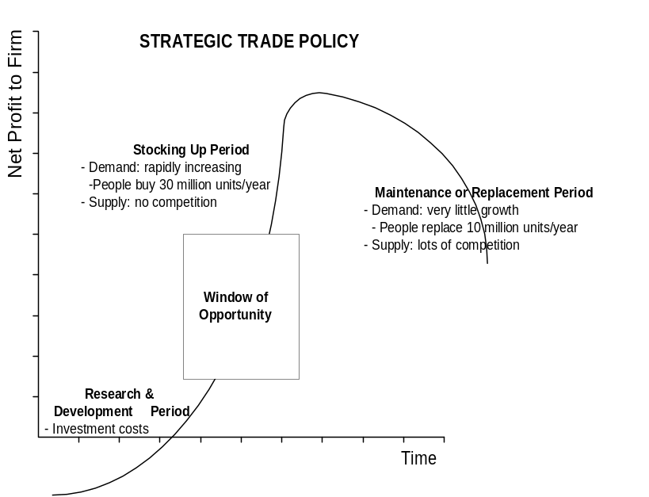
- The product life cycle indicates that there is a window during which a new product faces very little competition and can lead to substantial profits for a country.
- Protection can increase the chances of research and development leading to a new product and the establishment of profitable industry.
- The larger the potential market, the lower the price these firms can set in order to recover their costs.
- There is a great deal of risk that these products may fail, and with the product life cycle, the window in time may be fairly narrow before a great deal of competition enters.
- A few firms, early in the game may make a great deal of profit. Those firms that are able to establish themselves may be dominant in the future.

- If the govt. subsidizes the industry, the profits may be so substantial that they more than repay the costs of the subsidy through increased future tax revenue.
- Protection through tariffs is another alternative which reduces the need for subsidies for a govt. which is short of money.
- The Japanese protect a new industry, restrict the number of companies in the industry, promote domestic competition to stop inefficiency problems associated with infant industries, and eventually open the sector up to international competition. Often the Japanese firms are the strongest in the world.

- Such strategic trade policies require either subsidies or tariff protection during the product development stage.
- Problems: if all countries tried to pursue these policies, there would be an enormous waste of money as only a few companies will emerge the winners.
- Govts. are notoriously bad at picking winners, and it is not clear that they would support enough winning industries to compensate for the losing ones.

- Other countries will retaliate because they will lose key industries and product manufacturing to countries that have pursued these trade policies. This could trigger a trade war.

Learning by Doing
- Protection allows workers and managers to learn by producing, a comparative advantage can be created and the whole LRAC falls.
- It also allows for a rural urban shift to take place in which rural workers move to the cities and learn new industrial skills.
- Problems with this type of protection:
- Govt. is usually no good at deciding who the winners will be.
- Protected industries may lose the ability to adapt to competition: they often grow so weak that they need continued protection in order to survive.

Means to overcome a balance of payments disequilibrium
- OPEC has demonstrated that it is possible to intervene in markets and turn the terms of trade in favour of large suppliers.
- Not only can large suppliers restrict supply, but large purchasers can also group together to restrict demand to force the terms of trade in their favour.
- Countries will use protectionism to avoid any balance of payments disequilibrium that may result from such actions.

Anti-Dumping and Unfair Trade Practices
- To prevent foreign industries from gaining an advantage through unfair trade practices, the WTO permits countries to impose two types of tariffs: andti-dumping and countervailing duties
- Anti-dumping duties are imposed to prevent foreign firms from selling goods at prices below production costs for the exporter in the foreign country.
- Dumping occurs when a country wants to get rid of surpluses or as predatory techniques for destroying the industry in another country.
- The allowance of anti-dumping duties under GATT has helped to redress this unfair trading practice.
- However, tariffs have often stayed in place permanently:
- Producer prices in the domestic market become a minimum price, any attempt to sell below that price is met with an anti-dumping tariff to raise it back to the producer price level.

- The use of subsidies in many countries allows exporters to sell into foreign markets at prices below the costs of production.
- In retaliation, the importing country govt. is permitted to impose countervailing duties up to the amount of the subsidy.

4.2.4 Arguments against Protectionism

Inefficiency of resource allocation
- The products of low wage countries will drive out domestic products, and the domestic high standard of living will be dragged down. Counter arguments:
- Consumers gain when they buy products cheaply because they are made with cheap labour.
- Gains from trade depend on comparative not absolute advantage. Imports must equal exports, we can only import if we have already sold our exports to some other country.

- Exports raise national income while imports lower it. Counter argument:
- If more goods are sent abroad than are received at home, the total goods available for domestic consumption must fall.
- The gains from trade only come about from the increased consumption of foreign goods at lower than domestic prices.

Costs of long run reliance on protectionist methods
- As long as there is a schedule to remove tariffs, infant industries will learn to grow up and compete internationally.
- If we continue protection for infant industries, the difference between their costs and the costs of international competitors will become capitalized into the cost structure of the companies.
- That is, instead of being cost minimizers, infant industries will simply allow costs to rise to the import prices plus the tariff. They will never become economically efficient.

Increased prices of goods and services to consumers
- Trade can never be mutually beneficial, one partner always reaps the gain at the other's expense. Counter argument:
- The principle of comparative advantage shows: it is possible for both to gain, but it is the terms of trade which determine the distribution of these gains.
- Imposing tariffs will raise the price of imports for consumers.

The cost effect of protected imports on export competitiveness
- Don’t buy foreign goods, keep the money at home to provide jobs. Counter arguments:
- Foreign countries can only buy exports from your country if your currency can be purchased internationally to buy your exports. That money can only get there if you have imported goods and services from other countries.
- It is only because the domestic currency can be used to purchase domestic goods that foreign countries want it.
- If we continue to protect our import competing industries, we will never develop the competitive cost structures needed to sell exports. We need foreign competition to make us more competitive.

4.3 ECONOMIC INTEGRATION

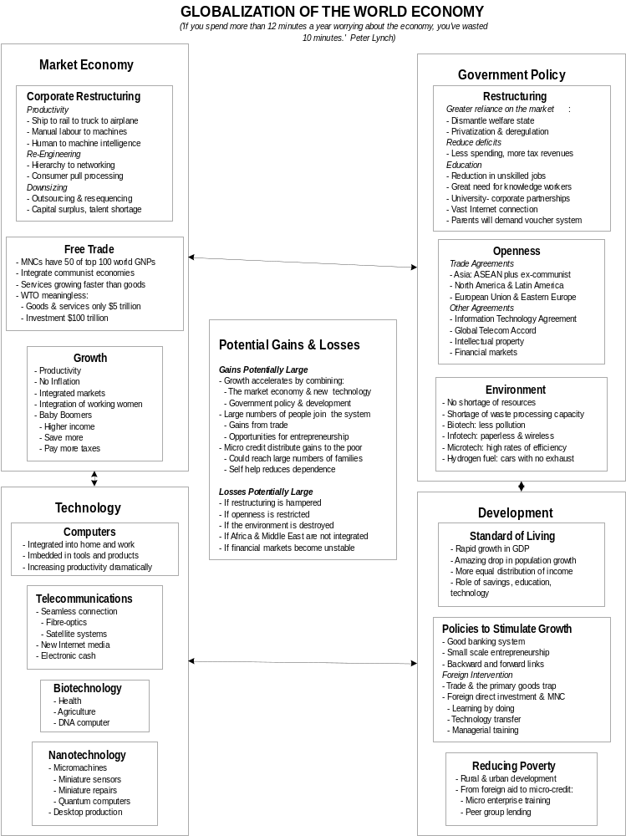

4.3.1 Globalization

Defining Globalization
- In the industrialized countries (DC or MDC) there is a fear that the forces of technological change and geographical shifts in the location of economic activities are transforming employment prospects in adverse ways, particularly for the less educated and less skilled.
- The disparity between rich and poor countries widens and environmental change continues.
- A hundred years ago only rare products such as spices and some basic raw materials were involved in international trade. Today virtually everything is involved.
- There is a new global division of labour:
- Originally the DCs produced manufactured goods
- The LDCs supplied raw materials and agricultural products, and provided markets for some of the exports of manufactured goods from DCs.

- Today, large scale, assembly line production has shifted to more flexible systems. There has been a shift toward information or knowledge driven processes, including a new global financial system.
- Hyperglobalists believe that nation states no longer matter, consumer tastes and cultures will be homogenized and serviced with products created by Transnational corporations (TNCs).
- Others claim the world was much more international 130 years ago, and that the world has simply returned to an international trading system, not globalization.
- The truth lies in between, there has been extensive integration of production networks unlike anything before:
- There is an internationalizing of economic activities which reflect quantitative changes leading to a more geographical pattern.
- There is a globalizing process where there is a functional integration reflecting qualitative changes in internationally dispersed activities.
- Different regions reflect different degrees of functional integration and geographic extent ranging from the EU to smaller Free Trade Agreements (FTAs)

Production Networks
- Relational structures are fundamentally different today:
- Production chains are linked sequences of functions where each stage adds value to the process of production.
- There are four basic elements:
- Inputs of materials and services
- Transformation of inputs into intermediate or final goods and services
- Distribution of goods and services
- Consumption of goods and services

- Technology plays a critical role at each stage, the financial system provides investment and operating capital, and management is required to coordinate, regulate and control.
- Services have come to play a critical role because they provide geographical and transactional connections and they integrate and coordinate all the small parts of the global system.
- It is the TNCs that play the key role of coordinating production networks which include:
- Externalized transactions which are coordinated through market systems, typically called out-sourcing
- Internalized transactions which occur in a vertically integrated system, typically called in-house.

- Production networks are dominated either by producers or consumers:
- Producer driven production networks are dominated by TNCs in capital and technology intense industries like cars.
- Buyer driven production networks occur where there are large retailers or brand name producers such as in clothing.

- Global production networks are not arrayed in a hierarchical fashion. Every component is grounded in the sense that they have a physical location in which they have sunk costs and localized social relationships and cultural practices.
- All elements are regulated within some political structure whose basic unit is the nation state but which includes international agencies such as WTO
- TNCs attempt to take advantage of national differences in regulatory regimes, whereas states attempt to minimize regulatory differences.
- The global economy is structured and re-structured by the complex, ever changing interactions between TNCs and nation states.
- It is at the points of intersection where the problems exist, whether private enterprise, govt., a local community or individual, and where they have to be solved.
- There are forces for both concentration and dispersal, but with a strong tendency toward agglomeration into localized geographic clusters.

Historical patterns of production clusters
- There may be positive spillover effects:
- These structures may lead to urbanization economies where activities agglomerate in urban centers.
- Structures may also form due to specialization or localization economies where functions are linked in particular production networks. This may lead to direct transactions between firms as well as interdependencies such as a shared pool of labour, particular kinds of institutions such as universities and govt. institutions.

- Typically these clusters originated by historical accident, but once established, the cumulative self-reinforcing development:
- Attracts linked activities
- Stimulates entrepreneurship and innovation
- Deepens and widens the labour pool
- Fosters local institutions
- May lead to enhancement of physical infrastructure (external economies of scale).

- The economy can get locked into a pattern because of historical precendent.
- Globalization therefore is the linking together of a network of organizational or functional relationships in the production network and the geographical or localized cluster of economic activity.

Negative Externalities or Spillovers
- Negative externalities or spillovers typically relate to environmental damage and include:
- Over-exploitation of both renewable and non-renewable resources: over-fishing and the rapid running down of world oil reserves.
- Over-exploitation of environmental waste processing capacity typically seen in the greenhouse gasses and the landfill problems
- Destruction of ecosystems to create space for urban and industrial development.

- Typically natural and environmental resources enter in a state of low entropy (useful order) and leave in a high state of entropy (useless disorder).
- Even with renewable resources such as fisheries, they will become exhausted unless managed in a sustainable manner
- With non-renewable resources, the more we use today, the less will be available tomorrow unless there is a massive technological breakthrough.
- Global warming is certainly the most serious of the environmental externalities which may have very serious consequences for future generations, not the least because it may be irreversible.
- The environmental problems inherent in globalized production systems raise serious questions about the sustainability of economy and society. They have become a major part of the globalization debate.

4.3.2 Trading Blocs

Free Trade Areas
- Trade restrictions between member states are removed but each state retains the right to use trade policy against non-member states.
- The world has evolved into three major trading blocks: the EU, NAFTA and the Japanese dominated investment/subcontracting trading area in the Asia Pacific.
- In 1989 the US and Canada signed a free trade agreement. In 1994 this was expanded to include Mexico. In 2001 agreement was concluded amongst 34 countries in the Americas to establish a free trade area of the Americas.
- There are a number of smaller trading blocks including:
- ASEAN: the association of South East Asian Nations, currently the group is considering a free trade area with China, South Korea and Taiwan.
- LAFTA: the Latin American free trade area
- CARICOM: the Caribbean community
- Mercosur: involving Argentina, Brazil, Bolivia, Chile, Paraguay and Uruguay.
- A free trade agreement requires a value added agreement, otherwise a member of the group could lower external tariffs and ship goods through without tariffs from a country which would normally face high tariffs in the importing country.
- Levels of protection and integration between economies in trade groups or blocks:

Trade Agreement Table
 | Free Trade Agreement | Customs Union | Common Market or Economic Community | Economic Union
No tariffs quotas or export subsidies amongst members: free movement of goods and services amongst members | √
Value Added agreement: goods can only be re-exported to a member country if a certain specified amount of value has been added to the product after it was imported from a non-member country. | √
No internal barriers and a common external tariff: free movement of goods and services (harmonized trade policy) |  | √ | √ | √
Free movement of capital and labour |  |  | √ | √
A common currency and free movement of investment capital (harmonized fiscal & monetary policy) |  |  |  | √

Customs Union
- A customs union is a group of countries who agree to free trade amongst themselves and a common set of barriers against imports from the rest of the world.

Common Markets
- A common market includes free trade amongst member states and a common tariff for non-member imports. There is also complete mobility of factors amongst member states.
- An economic union includes a common market plus the eventual harmonization of monetary and fiscal policies. The best example is the European Union (EU) which recently signed an agreement with European Free Trade Association (EFTA) making the combined group the largest free market in the world.
- Norway did not join although it has special trading arrangements with the EU.
- In 1999 European Monetary Union was established among 11 member states. The UK did not join for fear of losing economic sovereignty.

4.4 WORLD TRADE ORGANIZATION

Aims
- Since 1945 trade policy has tended to be set within an international institutional framework. Until 1995 this was the General Agreement on Tariffs and Trade (GATT) and since then it has been the WTO.
- The WTO depends on a rule based multilateral trade cooperation which does not focus on outcomes such as market share or growth, but simply attempts to establish the general conditions for competition facing exporters.
- The larger the country, the larger its inter-regional trade and the smaller its international trade.
- In many smaller countries (Canada and the Netherlands), international trade can represent a very large proportion of total GDP.
- For LDCs economic development often involves the production and export of basic commodity items usually involving natural resources in a sequence beginning with the ones with the greatest comparative advantage.
- LDCs put tariffs on imports to encourage the creation of a manufacturing sector.
- As they become more integrated into world trading systems, growth increases and employment opportunities increase because of the gains from trade.

- Both industrialized countries and NICs have done well out of GATT regulated trade. This has not been the case for LDCs which are very poor or for those which have specialized in primary products.
- The WTO predicts that by 2005 there may be as many as 250 regional trading agreements covering more than 50% of trade. Such regional arrangements could damage the rules based multi-lateral trading arrangement fostered by WTO.

Trade in Services
- Future growth in trade will be dominated by services.
- At most, trade in goods will double over the next century.
- Trade in services is already larger than trade in goods, and growth will be much faster.
- In order for there to be free trade in services, each country must extend the principle of right of establishment and national treatment to the other country's firms that sell services.

- Firms selling services in one country have the right to establish in the other country and be treated the same as local service firms.
- Negotiations continue in WTO to complete an international agreement on financial services which would move it to a rules based multi-lateral system as for trade in goods. An interim arrangements was reached in 1995 which covered banking securities and insurance.

Multilateral Trade vs. Free Trade Agreements
- Under WTO (GATT), multilateral trade has increased enormously, but free trade agreements have reduced the impact of multilateral trade.
- Free trade agreements remove the tariffs between states but leave in place each nation’s tariffs against foreign countries.
- To prevent trans-shipping of imports through countries with low tariffs, there is usually a value added agreement in place.
- For example, NAFTA does not permit any good to be imported from outside the group and re-exported to a member of the group unless 35% of the value has been added by the original importing country.

- Under WTO average tariffs amongst member countries are less than 4%. Thus free trade agreements do very little to remove tariff barriers. Instead what they do is allow countries to specialize in producing those products where they can achieve minimum efficient scale (where full economies of scale are realized).
- Most states in the agreement continue to produce most products, but there are fewer product lines.
- Exports increase in certain product lines and imports increase in others.

- There is an increase in intra-industry trade through this type of rationalization.
- Competition from Japan and Europe has convinced the US of the need to protect against loss of competitiveness, hence their desire to form NAFTA.
- Under multilateral trade there is no need for trade to be reciprocal, it does not matter who you export to or import from. But with free trade agreements, the scope for trade is narrowed considerably.

Successes and Failures
- More than 140 countries are members and have agreed to several rounds of tariff cuts. It also has developed a code of conduct relating to unfair trade practices.
- The Kennedy Round was completed in 1967, the Tokyo round in 1986, and the Uruguay round in 1995.
- The Uruguay round: negotiations began in 1986, agreement was reached in 1996:
- The agreement reduced non-tariff barriers, liberalized trade in services, reduced domestic subsidies to agriculture, created better dispute settlement mechanisms, and better copyright protection for intellectual property.
- A current controversy surrounds the proposed Multilateral Agreement on Investment (MAI) which would take a great deal of power away from govts. and give it to companies investing in a country.

- International protest groups oppose the WTO, the World Bank and the IMF as they feel they are dominated by leading industrialized countries, particularly the US.
- The most difficult areas facing the WTO in the future will be:
- The reduction of agricultural subsidies in all industrialized countries which should open these markets to LDCs
- The establishment of a trade in services agreement
- The integration of China which will strain trading systems as well as impose new obligations on China to conform to WTO rules.
- The development of a more equitable world trading system where the power of developed countries is not imposed on LDCs through various kinds of conditionality and trade-opening requirements.
- Developed countries must operate a fairer system of access to their own markets for poorer countries.

4.5 BALANCE OF PAYMENTS

4.5.1 Current Account

- External equilibrium is concerned with the Balance of Payments: An account of the transactions between domestic and foreign economies.
- The current account includes the trade account which records the goods and services imported and exported from the home country.
- A deficit on the trade account means that imports are larger than exports.
- Those items which lead to Europeans receiving money from abroad are counted as positive items in the balance of payments.
- A more technical definition: those items which lead to more Euros being purchased are counted as a positive item on the Balance of Payments.
- The current account:
- Records all international transactions involving goods and services.

The Balance of Trade
- Merchandise account: also called the visible account in Britain, which records all transactions involving goods.
- The Traded Service account which records all transactions involving services.
- The Capital Servicing account:
- Includes the interest, profits and dividends paid to and by foreigners.
- For developing countries, this section is usually negative. More is paid out to foreign investors than is received as interest and dividends.
- For industrialized countries like the US and Japan, this account is typically positive because of the large amount earned on foreign investments.

Invisible Balance
- Consists of the Capital Servicing account plus the Traded Services account.

4.5.2 Capital Account

- The capital account records financial transactions involving short term and long term capital movements into and out of the country.
- When financial capital flows into a country, that country is exporting a security to the foreigner.
- The security can consist of a money market instrument, a bond, a stock or a joint venture agreement or some kind of contractual arrangement.
- When those securities are exported, financial capital flows into the domestic economy and counts as a plus in the Balance of payments.

- Capital account: if the Japanese invest in US treasury bills, it is the US that gets the money, and the Japanese that get the TB's.
- It counts as negative on the Japanese balance of payments (and their GDP).
This is how the balance of payments is always balanced: if there are negatives on the current account, they must be balanced by a plus on the capital account.
- Short term capital is held mainly in money market instruments such as treasury bills or bank accounts (portfolio as opposed to direct investment).
- Long term capital movements:
- Portfolio: generally involve the purchase of stocks or bonds.
- Direct: investments in capital in the country or joint venture agreements.

- As an alternative to short term and long term, the Capital account is divided by:
- Direct investments: which includes direct investment in a branch plant or a subsidiary for a large multinational company or a joint venture agreement
- Portfolio investments: which includes transactions involving securities such as money market instruments or stocks and bonds.

Official Reserves
- If we include official reserves, the balance of payments is always in balance.
- One of the easiest ways to think about it is to ask who gets the money.
- Current account: if Japan imports apples from China, the Chinese get the money, the Japanese get the apples. It counts as a minus in the Japanese balance of payments (and for the GDP).
- If the Chinese buy cars from Japan, the Chinese get the cars and the Japanese get the money: a plus on Japan’s balance of payments.
- For services: if the Japanese go skiing in Switzerland, the Swiss get the money, and the Japanese get the tourism experience. It enters as a negative on the Japanese balance of payments.

- Factors influencing the balance of payments include:
- Income: as national income rises the demand for imports rise shifting the current account toward a deficit.
- Changes in relative prices: as domestic prices rise relative to foreign prices, imports appear cheaper and exports more expensive and the current account will move toward a deficit.
- Changes in relative investment prospects: as return on investment rises, foreign capital will be attracted into the country and the capital account will move toward a surplus.
- Changes in relative interest rates: as domestic interest rates rise, short term capital is attracted moving the capital account toward a surplus.

- If the foreign exchange rate is rising (domestic currency appreciating), the central bank may intervene by selling more domestic currency.
- If the foreign exchange rate is falling (domestic currency is depreciating), the central bank may intervene by buying domestic currency with the reserve of foreign currency.

4.6 EXCHANGE RATES

History of Exchange Rate Systems
- For several centuries the developed world operated under a fixed exchange rate system based on the gold standard. The system worked well until WW1 and the rapid changes occurring due to industrialization.
- After the depression in the 1930s many systems were tried, but the developed world chose to switch back to a fixed exchange rate system after W.W.II.
- This was called the Bretton Woods system and included the creation of the IMF (International Monetary Fund).
- This system was finally terminated in 1973 but the IMF survived. What followed was a system called the adjustable peg which gave way to a short period during which rates were floating under a flexible exchange rate system.
- This has been followed in more recent times by a managed float system.

Modern Exchange Rate systems
- The Euro exchange rate is the value of the Euro in terms of another currency.
- The exchange rate is the amount of foreign currency paid to obtain a unit of the home currency (this is the definition used by the IB)
- If the exchange rate rises, the home currency appreciates, more of the foreign currency is needed in order to purchase the home currency.
- If the exchange rate falls, the home currency depreciates, less of the foreign currency is needed to purchase the home currency.
- Except for the US$, the Euro € and the Japanese ¥, most currencies are only acceptable within the borders of the home country. Thus exporters must eventually receive payment for the goods that they export in terms of the currency of their own country.

- A trade weighted exchange rate index measures the value of the Euro in terms of a basket of currencies which are weighted by the proportion of trade between those countries and Europe.
- The effective exchange rate examines how much trade Europe has with the other country and the extent to which Europe competes with these other countries in terms of trade.
- The real exchange rate takes into account the effects of inflation. If the Euro falls by 5% against the Yen but there is 5% inflation in Europe, the real exchange rate is assumed to be unchanged.

- If Europeans sell software and the Japanese sell cars:
- Europeans who want to import Japanese cars will need Japanese ¥, and they provide the demand for Japanese ¥ and the supply of Euros.
- Japanese who want to buy European software need Euros and they provide the demand for Euros and the supply of Japanese ¥.

4.6.1 Fixed Exchange Rates

- Under the fixed exchange rate system rates are fixed at some value and the central bank intervenes to ensure it stays at that agreed upon rate:
- For centuries the standard was gold
- Some countries fixed their exchange rates to a currency like the British pound which was convertible into gold.

- From 1946 to 1973, most countries pegged or fixed their currencies to the US dollar.
- In the face of short term fluctuations, the central banks of each country would intervene in the market and buy and sell US$.
- As long as the central bank worked around equilibrium, then on average it would buy about as much as it sold and the policy did not lead to changes in foreign currency reserves.
- More recently governments of smaller countries have fixed their currency to a ‘key’ currency such as the dollars, Yen or Euros with periodic adjustments.
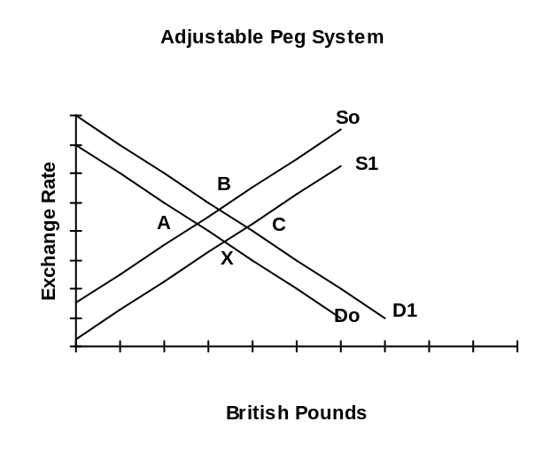
- If there is a fixed or adjustable peg system, and the demand for foreign currency shifts out (from Do to D1) because greater domestic inflation has led to an increase in the demand for imports and a fall in the demand for exports:
- There will be pressure on the domestic currency to depreciate (exchange rate rises from A to B).

- If there is a permanent switch away from the agreed on rate, the central bank will be faced with constantly buying or selling to maintain the old rate.
- If there is more inflation in the domestic economy than in the foreign, the exchange rate should be rising or the domestic currency should depreciate.
- With flexible exchange rates, the domestic currency would do exactly that. But this is not permitted under the fixed exchange rate system.

Current Account Adjustments
- The govt. imposes tariffs or quotas on imports, or exchange controls or it could subsidize exports:
- This leads to a fall in the demand for the foreign currency from D1 back to Do (B back to A)
- It may lead to retaliation from other countries especially under GATT.

- The govt. can subsidize exports:
- This leads to an increase in demand for exports which means the supply of foreign currency shifts out from So to S1 and we move from point B to C
- It may lead to countervailing duties from other countries.

Capital Account Adjustments

Foreign Exchange Reserves
- Foreign reserves are often held in the form of US$ with only small amounts held in ¥ and the Mark.
- Each member country of the IMF is assigned a quota of (SDRs), rather like a bank account or a type of currency issued by the IMF (International Monetary Fund). .
- SDRs can only be used to cope with balance of payments problems.
- Central banks are reluctant to see the system expand because most govts. have shown irresponsibility when it comes to controlling the money supply.
- Private acceptance of SDRs has been almost non-existent indicating the tremendous influence of the US$.

- Effectively the central bank in the US, called the Federal Reserve Board, is the central bank for the world.
- There have been calls for a return to the gold standard, but there is a shortage of gold which would lead to further crises.

- Most central banks keep SDRs, US$, some gold, some ¥, and some Euros
- With downward pressure on the exchange rate, and if the country holds foreign exchange reserves, the govt. can tell the central bank to buy domestic currency:
- Supply of foreign currency shifts right (from So to S1 in above diagram) which brings the exchange rate back down to the original level (from B to C).

- The govt. can tell the Central Bank to increase interest rates (M^{s} contracts):
- This leads to increased capital inflows which means that the supply of foreign currency shifts out from So to S1 (move from point B to C).
- Domestic citizens stop buying foreign money market instruments, and demand shifts left (move from point C to X)
- Effect on the domestic economy:
- Domestic prices fall: S shifts right, D shifts left: exports rise and imports fall.
- This may lead to a recession in the domestic economy: D shifts left, imports fall.

- If these policies do not work, the govt. will tell the Central Bank to devalue the currency which may lead to competitive devaluations by other countries.

4.6.2 Floating Exchange Rates

- Under the flexible exchange rate system, rates are allowed to float.
- The purchasing power parity theory assumes floating exchange rates adjust until a unit of currency can buy the same basket of goods and services as a unit of another currency.
- Currencies are allowed to float and govt. intervenes periodically to influence the price but does not set the price. The currencies are kept within some limits.

- If the exchange rate is denoted as the number of Yen required to purchase a Euro. If it is below equilibrium: there will be excess demand for European Euros
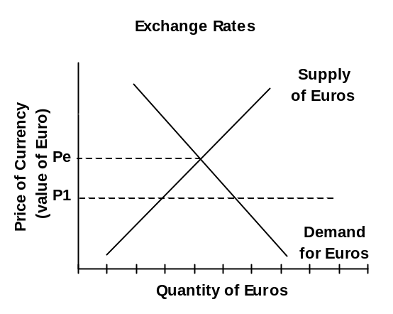

- Traders who need Euros will start bidding up the price:
- As the supply curve is upward sloping, the quantity supplied of Euros will rise. The extent of the increase will depend on the elasticity of supply.
- As the demand curve is downward sloping, the quantity demanded of Euros will fall.
- The extent of the fall will depend on the elasticity of demand.

- As the exchange rate rises:
- Exports of software start to fall as it becomes relatively more expensive
- Imports of Japanese cars will rise as they become relatively cheaper.
- The two effects will finally lead to supply equal to demand in equilibrium.

- If the exchange rate is above equilibrium:
- There will be an excess supply of Euros
- Japanese cars look relatively cheaper so Europeans start offering more Euros for Yen and the price of Euros will start to depreciate in value.
- As the supply curve is positively sloped, fewer Euros are offered as the value of the Euro depreciates. The more elastic the supply, the greater the impact on quantity supplied.
- As the demand curve is negatively sloped, the lower value of the Euro starts to make European software look cheaper and more will be demanded. The more elastic demand, the greater the impact on quantity demanded.
- The two effects will finally lead to supply equal to demand in equilibrium.

Shifts in Demand & Supply
- Europeans demand Yen to buy goods and services from Japan, and to invest if the return on investment is greater in Japan.
- If Europeans want more Japanese goods and services or if they want to invest more in Japan, the supply of Euros will shift to the right. If the Japanese demand for Euros does not increase, then the exchange rate depreciates.
- If Japanese want more European software or if they want to invest in European securities, the demand for Euros shifts to the right and the exchange rate will appreciate.
- The most common causes of shifts: some affect one rather than both demand and supply (denoted in brackets):

ROI or interest rate effect (two sided):
- If return on investment or the interest rate increases in Japan, or if currency speculators believe the value of the Yen will rise in the future:
- The supply of Euros will shift to the right. More Euros will be offered for sale.
- The Japanese will be less interested in investing in Europe. Fewer Euros will be demanded.
- The outward shift in supply and inward shift in demand leads to a depreciation of the Euro.

Income effect (one sided):
- If the income in Japan rises, the demand for Euros will shift out, more Yen will be offered for Euros, and the Euro will increase in value

Price inflation (two sided):
- If there is inflation in Europe but not in Japan, Japanese cars will appear to be relatively cheaper, and more cars will be sold in Europe, more Euros will be offered for sale for Yen.
- The supply of Euros will shift out, and the Euro will depreciate in value.
- At the same time, European software will be relatively more expensive in Japan, so the demand for Euros will shift in to the left.
- The outward shift in supply and the inward shift in demand leads to a depreciation in the exchange rate.
- If both countries have the same amount of inflation, the two sets of shifts offset each other.
- The country experiencing a more rapid rate of inflation will also experience a steady depreciation of its currency.

Growth or productivity effect (two sided):
- Rather similar to the price inflation, only in this example it is costs which are falling in the country with the higher growth rate or more rapid increase in productivity. If labour productivity rises faster in Europe then goods look relatively cheaper in Europe:
- The demand for Euros will shift to the right.
- The supply of Euros shifts in.
- This leads to an increase in the value of the Euro.

4.6.3 Managed Exchange Rates

- The managed float is basically a flexible exchange rate system in which rates are permitted to float, but the central bank intervenes on a regular basis to keep the rate within some agreed upon limits.
- Govt. can influence exchange rates, usually through the Central Bank by:
- Buying and selling both domestic and foreign currency
- Altering interest rates in order to influence short term capital flows
- Altering return on investment through tax policies in order to influence long term capital flows.
- Rather than managing a single currency, for several years the EU has attempted fixed exchange rates amongst its member countries but a managed external float as a block against the dollar and the Yen.
- This broke down in the fall of 1992 and was replaced in 1999 by the European Monetary Union which consists of 11 member countries.

- If interest rates rise in Canada, investors from Britain will buy Can$ money market instruments until the appreciation in the value of the Can$ which results is just equal to the differential in the interest rates.

- The expected future depreciation of the Can$ is just enough to bring Canadian interest rates back down to the international equivalent.
- If interest rates are 5% higher in Canada, investors will keep on investing until the exchange rate has fallen by 5% (Can$ has appreciated by 5%).
- The extra 5% interest earned is enough to offset the 5% future depreciation of the Can$.
- The appreciation puts export and import competing industries at a competitive disadvantage.

4.6.4 Depreciation vs Devaluation; Appreciation vs Revaluation

- Under a floating exchange rate system, the exchange rate:
- Depreciates whenever it falls in value against other currencies:
- Less foreign currency is needed to purchase a unit of domestic currency
- Appreciates whenever if rises in value against other currencies:
- More foreign currency is required to purchase a unit of domestic currency.

- Under a fixed or adjustable peg system, rates are set every day by the central bank but are periodically adjusted:
- If the Central Bank devalues the currency it is equivalent to a depreciation in the currency or an increase in the exchange rate:
- It costs more domestic currency to buy foreign currency.
- If the Central Bank revalues the currency it is the equivalent of an appreciation of the currency or a fall in the exchange rate:
- It costs less domestic currency to buy foreign currency.

4.6.5 Effects on Exchange Rates
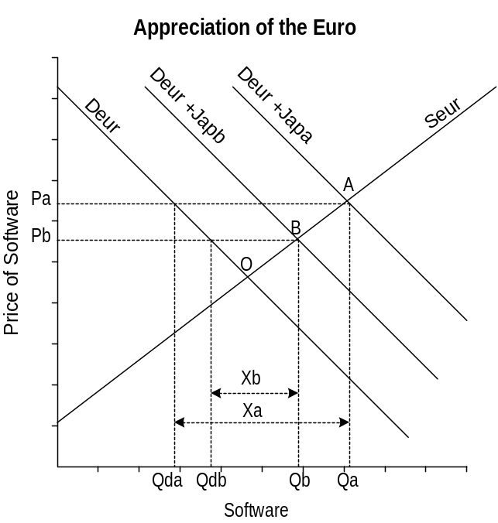

Trade Flows: Appreciation of the Euro

Software Market
- In the figure, D_{eur} and S_{eur} represent the domestic supply and demand for software. The no trade point of equilibrium is O with no exports.
- D_{eur +Japa} represents the domestic European demand plus the Japanese demand for European software. Total European production is Qa of which Qda is consumed in Europe and Xa is exported to Japan.
- If the Euro appreciates, the foreign price of European software will rise:
- Japanese demand will fall to Jap_{b}
- Exports will fall to X_{b}
- Price will fall from Pa to Pb.
- Domestic consumption rises from Qda to Qdb.
- Exports decrease to Xb.

Car Market
- In the figure, D_{eur} and S_{eur} represent the domestic supply and demand for cars. The no trade point of equilibrium is O with no imports.
- S_{eur +Japa} represents the domestic European supply of cars plus the Japanese supply. Total European consumption is Qa of which Qda is produced in Europe and Ma is imported from Japan.
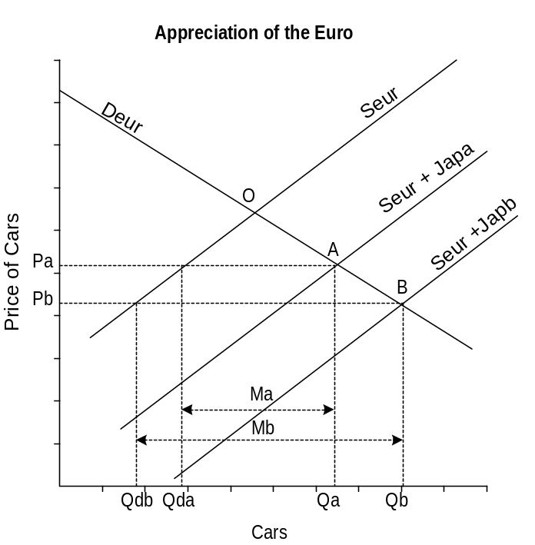
- If the Euro appreciates, less Euros must be paid to obtain the required amount of Japanese ¥. The European price of Japanese cars will fall:
- The supply curve shifts out from S_{eur +Japa} to S_{eur +Jap b}.
- Domestic production of cars falls from Qda to Qdb.
- Imports of Japanese cars rise to Mb.

Trade Flows: Depreciation of the Euro

Software Market
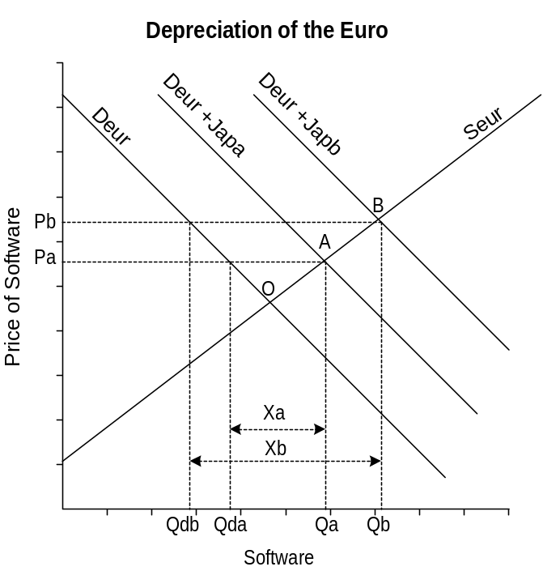
- In the figure, D_{eur} and S_{eur} represent the domestic supply and demand for software. The no trade point of equilibrium is O with no exports.
- D_{eur +Japa} represents the domestic European demand plus the Japanese demand for European software. Total European production is Qa of which Qda is consumed in Europe and Xa is exported to Japan.
- If the Euro depreciates, the foreign price of European software will fall:
- Japanese demand will rise to Jap_{b}
- Exports will rise to X_{b}
- Price will rise from Pa to Pb.
- Domestic consumption falls from Qda to Qdb.
- Exports increase to Xb.

Car Market
- In the figure, D_{eur} and S_{eur} represent the domestic supply and demand for cars. The no trade point of equilibrium is O with no imports.
- S_{eur +Japa} represents the domestic European supply of cars plus the Japanese supply. Total European consumption is Qa of which Qda is produced in Europe and Ma is imported from Japan.
- If the Euro depreciates, more Euros must be paid to obtain the required amount of Japanese ¥. The European price of Japanese cars will rise:
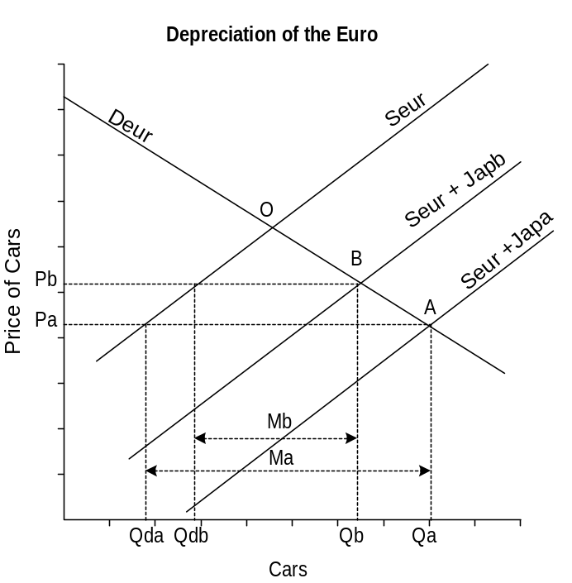
- The supply curve shifts in from S_{eur +Japa} to S_{eur +Jap b}.
- Domestic production of cars rises from Qda to Qdb.
- Imports of Japanese cars fall to Mb.

Capital Flows & Interest Rate Changes
- In addition to software, the Japanese may be interested in investing in Europe.
- If they buy securities they offer Japanese ¥ to buy Euros to pay for them, an outward shift of the demand curve.
- This leads to capital inflows into Europe and an appreciation of the Euro.
- If Europeans decide they want to buy more Japanese stocks, they will offer Euros (equivalent to an outward shift in the supply curve for Euros).
- This leads to capital outflows from Europe and a depreciation of the Euro.

- Interest rates (OCRR): a major reason for short term capital movements is differences in interest rates.
- If interest rates are higher in Japan, Europeans with short term funds will buy short term money market instruments in Japan. As they do so the foreign exchange rate falls leading to a depreciation of the Euros.
- To stop the depreciation of the Euros the Central Bank may decide to increase interest rates.

- Speculation about exchange rates can also lead to short term capital movements:
- If the Euro is expected to appreciate, Japanese investors will buy European money market instruments in anticipation.
- The increase in the supply of Japanese ¥, equivalent to an increase in the demand for Euros will force the exchange rate up and lead to an appreciation of the Euro. This is an example of self realizing expectations.

- ROI: long term capital movements are more related to expectations about profit opportunities than to future movements in exchange rates.
- If return on investment is higher in Europe, then money will flow out of Japan into Europe.
- If rates of return are consistently lower in Europe compared to Japan because productivity rises more slowly for a number of reasons, then there will be a slow but steady erosion in the value of the Euro.
- If return on investment is the same in both countries but investors expect the Euro to appreciate in the future, this may lead to greater long term investment.
- This case is much less likely as it is very difficult to predict exchange rate movements over the long term. Investors are much more sensitive to differences in ROI.
- If the exchange rate is expected to fluctuate greatly in the future, investors are much less likely to invest for fear of potential loss.

4.7 BALANCE OF PAYMENTS PROBLEMS

4.7.1 Consequences of a current account deficit or surplus

- If we define the current account as C, the capital account as K, and the official reserves account as F. We will find that:
- where R = receipts (received from foreign country, credit item)
P = payments (paid to foreign country, debit item)

- The sum of all transactions, payments and receipts must be equal. There must be a zero balance left over otherwise the currency will appreciate or depreciate.
- There does not have to be a balance within an account or between any two accounts. But there must be balance amongst all three accounts.
- There may be bilateral imbalances between countries, but each country must have a zero multilateral payments balance with the rest of the world.

Merchandise Account
- If imports of goods exceed exports, we get a deficit on merchandise account.
- This may be offset by a surplus on invisibles.
- If invisibles are in deficit, the current account as a whole will be in deficit.
- In some countries a deficit on the merchandise account is considered to be a bad thing and is referred to as an unfavourable balance of payments.
- But for developing countries it may be necessary to import machinery and other capital equipment in order to develop. In the short run there is a deficit but in the long run the new production may lead to a surplus.

Current Account
- A deficit on the current account can be offset by a surplus on capital account.
- Exports of securities means the country is a net importer of capital (remember who gets the money), usually associated with a LDC which may experience a great deal of foreign investment.

- If there is a surplus on the current account, this means there is more foreign currency being earned than domestic currency being paid out.
- The people who hold this money must do something with it, and presumably they will hold the foreign currency in the money market in the foreign country (thus importing financial securities).
- A surplus on the current account is offset by a deficit on the capital.

4.7.2 Methods of Correction

Using Official Reserves
- If both the capital account and the current account are in deficit, this can be offset by a surplus on the official reserves account.
- A balance of payments surplus means the central bank must be adding foreign exchange reserves to its holdings.
- A deficit means the Central Bank must be reducing its reserves.
- If the central bank did not intervene in the foreign exchange markets, a surplus or deficit can only be temporary and will be self correcting:
- If holders of Euros are trying to buy more Japanese ¥ than holders of ¥ are willing to sell because there is a deficit on the balance of payments, the Euros will depreciate until demand equals supply.
- At that point the balance of payments will also be in balance because imports look more expensive while exports look cheaper leading to an increase in exports and a decrease in imports until the balance of payments temporary deficit is eliminated.

- It is a popular myth that a country's external balance is similar to a firm’s profit and loss statement.
- If the country is not in surplus it is assumed to be in trouble. However, in order to keep the balance of payments in surplus, the currency must be persistently held below its equilibrium level. This requires a deficit in official reserves which means constant purchases of foreign exchange.
- This view was developed under the mercantilists, a group of economists who lived 300 years ago.
- The law of comparative advantage shows that average living standards are maximized by having individuals and regions specialize in the things they can produce best and trade for things in which they have a comparative disadvantage.
- The more specialization, the more trade. If this leads to a large volume of trade with a zero balance of trade, then all regions will be better off.

Managed Changes in Exchange Rates
- In most countries, the govt. is unwilling to allow the currency to float completely freely and it intervenes. The result is that surpluses will occur if the currency is persistently held below its equilibrium level or deficits if the currency is held above its equilibrium level.
- Most governments set target bands around the exchange rate:
- If the exchange rate approaches the upper band, the Central Bank will lower interest rates:
- This discourages short term capital inflows and fosters short term capital outflows leading to a fall in the exchange rate
- If the exchange rate approaches the lower band, the Central Bank will raise interest rates:
- This encourages short term capital inflows and motivates domestic investors to stop short term capital outflows.

- A group of countries was formed in 1982 which has since grown to seven and is called the Group of 7 (G7).
- While the G7 does not have the power to set exchange rates, it can reduce short term fluctuations and try to steer currencies closer to the PPP normal exchange rate equivalence.
- The IMF has also issued guidelines to central bank authorities to ensure an orderly adjustment process, to establish target zones with other IMF member countries, and to recognize that it requires team work among the member countries to ensure stability.

- One major problem still remains and that is the ease with which short term funds can flow between financial centres.
- These prevent the PPP normal exchange rate equivalents from being established.
- Italy has coped with this by establishing two separate exchange rate systems, one for the capital account and one for the current account.
- Germany has direct controls on overseas borrowing.

- There have also been suggestions that the flow of capital be restricted or slowed down through heavy taxes on unproductive (that is, speculative) capital flows.
- Problem: how does a central bank identify unproductive from productive flows of capital?
- Inevitably, black markets would form which would allow capital flows to avoid being tracked for tax purposes.

- Perhaps the most important feature has been the increased international cooperation which has allowed the international financial system to survive and weather the temporary crises which inevitably occur every few years. This is why institutions like the IMF and the G7 are so important for stability.

Internal and External Balance
- Internal balance is achieved when the level of national income is at the target level (Y* = Yfe).
- If there is entrenched inflation, the target may be a level of income below the full employment point (in order to eliminate inflationary expectations).

- External balance is achieved when a target level associated with the external sector is achieved.
- If the target is a zero trade balance (merchandise (visibles) account and the services account combined), when it is achieved there is external balance (this is the target assumed in the examples below).
- If the country is running a surplus in the capital account, the target may be a certain level of deficit in the trade balance. As long as this deficit is being achieved, there is external balance.

Conflict between internal and external balance
- A conflict between the internal and external balance occurs if in moving toward the internal target we move away from the external target.

Case 1: A trade deficit combined with a recessionary gap (Yo < Y*).
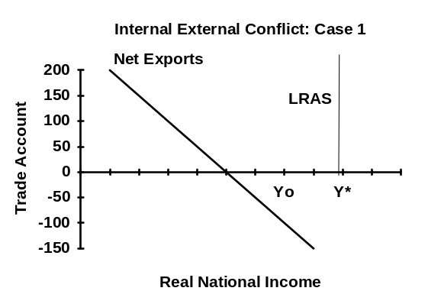
- As fiscal or monetary policy are used to move aggregate demand to the right to close the gap, imports will rise making the trade deficit worse.
- Internal balance is achieved at the cost of moving even further away from external balance.
- Because unemployment is considered a more serious problem than inflation, and a trade deficit as a more serious problem than a surplus, this case is considered the most serious and is referred to as a balance of payments constraint on domestic stabilization policy.
- In the long term, to prevent an exchange rate from falling, there is the possibility of using trade restrictions. However, under the WTO agreements, the threat of retaliation limits this policy tool. The main alternative for govt. is to deflate the domestic economy in order to reduce import spending.
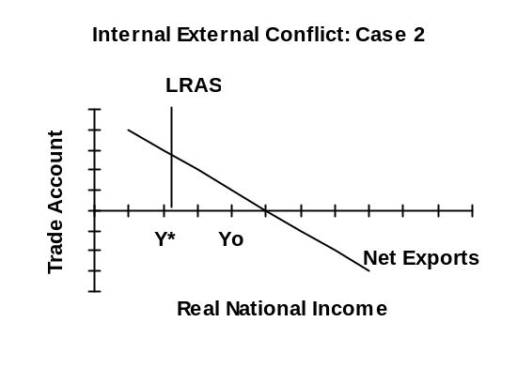

Case 2: A trade account surplus together with an inflationary gap (Yo > Y*).
- As fiscal and monetary policy are used to move the aggregate demand curve in to the left, there is a reduction in imports and an even larger trade surplus.
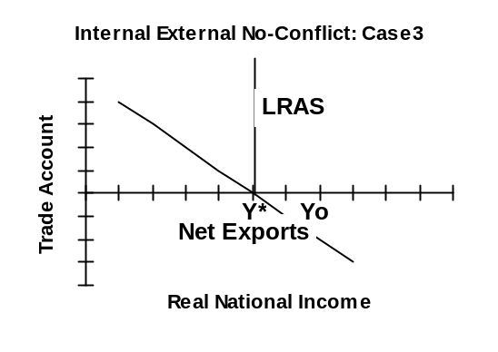

No Conflict between internal and external balance
Case 3: A trade deficit combined with an inflationary gap (Yo > Y*).
- As fiscal and monetary policy are used to close the gap, imports fall and the trade deficit is lowered simultaneously (expenditure reducing).

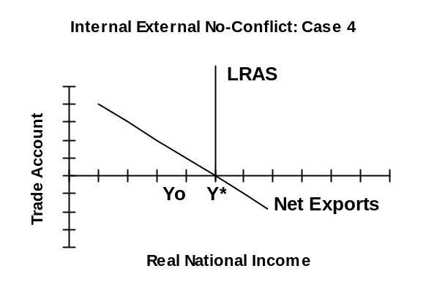
Case 4: A trade surplus combined with a recessionary gap (Yo < Y*).
- As fiscal and monetary policy are used to increase aggregate demand the gap is closed and imports rise lowering the trade surplus (expenditure increasing).

Expenditure Changing (Aggregate Demand) Policies
- The solution to the conflicting situation is to shift either the LRAS (supply side policies), or to shift the net export function.
- Internal balance is achieved when
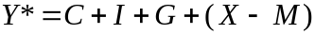
- If we refer to C + I + G = A as domestic absorption, then internal balance is given by
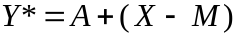
- This means that full employment income is equal to aggregate desired expenditures which is the same as domestic absorption plus net exports.

- Aggregate Demand management policies: actually affect the level of aggregate expenditures (policies that alter aggregate demand).
- Example of expenditure changing policies: in Cases 1 to 4 below, altering aggregate demand led to shifts along the net export line. Thus changes in the trade balance and national income are negatively related. A rise in Y worsens the trade balance and vice versa.

- Case 3: No-Conflict: trade deficit combined with an inflationary gap.
- In this case an expenditure reducing policy (AF shifted to the left) is appropriate to achieve both targets: this eliminates the inflationary gap while improving the trade deficit.

- Case 4: No-Conflict: a trade deficit and a recessionary gap.
- An expenditure increasing policy (AD shifted to the right) will achieve both targets: it eliminates the recessionary gap while reducing the trade surplus.

Expenditure Switching (Protectionism) Policies
- Expenditure switching policies: do not affect the level of expenditures but switch the proportions back and forth between absorption and net exports.
- This moves the net export function so that the trade balance is neutral at the full employment income point (net export line meets LRAS at the Y* point).
- Such policies include changes in exchange rates, tariffs and quotas, and altering differentials in inflation rates.
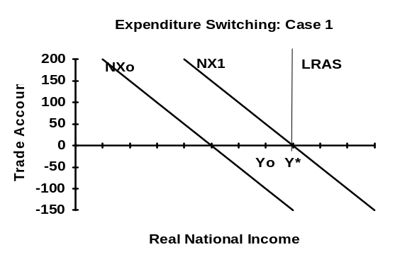
- Case 1: Conflict: trade deficit with a recessionary gap.
- Expenditure increasing policies are not appropriate.
- What is needed is a switch away from foreign goods toward domestic goods which reduces the trade deficit while increasing domestic absorption which reduces the recessionary gap (switch from foreign to domestic).
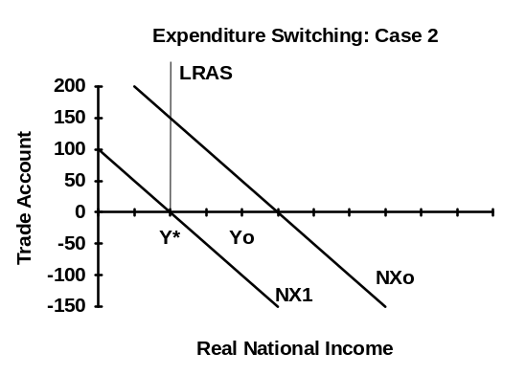

- Case 2: Conflict: a trade account surplus together with an inflationary gap
- What is needed is a switch in expenditure away from domestic goods toward foreign goods which reduces the trade surplus.
- At the same time, this decreases domestic absorption which reduces the inflationary gap (switch from domestic to foreign).

- The most important problem with expenditure switching policies is that trading partners are likely to retaliate with such things as exchange rate depreciation or the imposition of tariffs or quotas.

Changes in Supply side policies to increase competitiveness
- Supply side policies attempt to move the LRAS curve to the right
- By improving incentives, increasing the productivity of labour and capital, reducing input costs, and monopoly power.
- Not only does this shift the LRAS to the right but it leads to greater international competitiveness due to lower costs of production.
- This results in:
- A fall in imports and a rise in exports
- Upward pressure on the domestic currency.

4.7.3 Consequences of Capital Account Deficit or Surplus

- Capital flows are primarily influenced by interest rates which are part of monetary policy.
- Expansionary monetary policy leads to an increase in the money supply, a rise in the price of bonds, a fall in the interest rates, and an increase in domestic investment.
- This leads to an outflow of capital, the capital account moves toward a deficit.

- Expansionary fiscal policy leads to greater govt. borrowing which leads to interest moving up.
- Capital flows into the country moving the capital account toward a surplus.

- If we now expand the definition of external balance to include the whole of the balance of payments, then a deficit in the current account will be matched by a surplus on the capital account.
- If there is a temporary deficit in the balance of payments, the exchange rate will fall (depreciation) which will automatically lead to lower imports and greater exports.
- If the central bank does not want the depreciation to occur, it will intervene and purchase the domestic currency (the demand curve for Can$ shifts out: the supply of British pounds shifts out).
- The central bank will pay for this by cheques drawn on the commercial banks, thus there will be a contraction of the money supply.
- Canadian dollars leave the commercial banks and enter official reserves at the Central Bank.
- Interest rates will rise and capital will flow in, the exchange rate will rise (appreciates) again.
- If the central bank intervenes by increasing the money supply through open market purchases of bonds, interest rates will remain the same.
- The external effect is sterilized and the domestic money supply is insulated from the external effect.

4.8 TERMS OF TRADE

4.8.1 Definition of the Terms of Trade
- The division of the gains from trade depend on the terms of trade which measure the quantity of imported goods that can be obtained per unit of good exported:
- The ratio of the price of exports to the price of imports.
- The terms of trade change as the exchange rate changes, and the exchange rate changes as domestic prices change.
- If foreign inflation is higher, export prices will rise more slowly than import prices and the terms of trade worsen.
- Countries with higher productivity will produce lower cost goods and their export prices will rise less quickly than for other countries leading to a worsening of the terms of trade.

4.8.2 Consequences: Change in Terms of Trade on B of P
- A country may not experience the gains from trade due to specialization, if the terms of trade are not in its favour.
- Example: A rise in the price of imports leads to a decline in the terms of trade.
 | Opportunity Cost
 |  | Wheat | Cloth
India |  | 0.6 | 1.67
Kenya |  | 2.0 | 0.5
- If India specializes in wheat production, 1.67 bushels of wheat would have to be given up in order to gain an extra metre of cloth.
- If India can get 1 metre of cloth for 1 bushel of wheat by exporting it, then it is a good deal. It is better for India to specialize in wheat and trade it for cloth than it is to move resources out of wheat into cloth production.
- For Kenya, the costs of obtaining 1 more bushel of wheat is 2 metres of cloth. If they can trade 1 metre of cloth to obtain 1 bushel of wheat it is far better than moving resources out of cloth production into wheat.

4.8.3 The Significance of Deteriorating Terms of Trade for LDCs
- The term of trade for exporters of manufactured goods (mainly NIEs and DCs) have gone from 100 in 1960 to 80 in 2001.
- The terms of trade for exporters of primary goods (mainly LDCs) have gone from 100 in 1960 to 56 in 2001.
- Demand for primary products tends to be very price inelastic:
- Supply also tends to be price inelastic, and primary industries are subject to frequent supply side shocks for example in agriculture and mining.
- The combination of inelastic demand and supply can mean severe price volatility.
- Primary commodities tend to be income inelastic:
- Increases in world income put upward pressure on the prices of manufactured and service imports into LDCs without raising the prices of their exports.

